

An Information System for Smart Delivery Boxes

Project Proposal

**Project Advisor:**

Dr. Zeeshan Ali Rana

**Group Members:**

Muhammad Abdullah Zahid 21L-5764

Abdul Rafay Butt 21L-6095

Muzammil Hussain 21L-6051

National University Of Computer and Emerging Sciences

Department of Computer Science

Lahore, Pakistan

# Abstract

The increasing use of ecommerce globally has introduced challenges in the last mile delivery process as recipients often are not available. Due to this the number of failed attempts is increasing and delivery companies must make several attempts to deliver the parcel. The aim of this project is to address these challenges by developing a software solution for smart delivery box available in the market that optimizes last-mile delivery process. This will reduce delivery failures and increase accessibility for both customers and delivery services. Research has been done in developed countries like Japan, Sweden, and Finland where they have already applied this system which solved the problem and improved the last mile delivery process. The solution will include a web application which will manage the business process and mobile application which will allow users to track, send, and receive parcels. The delivery process will involve automated parcel handling, where delivery personnel use secure codes to access delivery boxes, and recipients are notified upon parcel arrival. The **Smart Delivery Boxes** have the potential to improve the last-mile delivery process, particularly in rapidly growing e-commerce markets like Pakistan. By automating the last mile delivery process and offering flexible pickup points, this system effectively reduces failed delivery attempts.

# Introduction

As the population is increasing with time, trends of eCommerce are also increasing [1]. Every shopping brand has almost spread over online shopping due to availability of home delivery service. It enables people to buy things from any available part of the world. With the time as number of users are increasing [1], some pros and cons are also coming to this field of area. Profits have increased as the number of buyers increased due to home delivery. On the other hand, the delivery process is getting pressurized as many times, the receiver of parcel is not available at destination. This increases the number of failed delivery attempts. According to our research, to tackle this issue, many companies in Sweden, Japan and Finland have implemented Smart Delivery Boxes for the last mile delivery process [2][3]. Instead of getting delivery to residence, buyers can incorporate with Smart Delivery Boxes where service providers can deliver parcel and receiver will get the parcel when he gets time. We expect that with this, the major problem of failed attempts will be decreased.

# Goals and Objectives

Primary goals and objectives are as follows:

* Automate the last mile delivery process for delivery companies.
* Let the sender and receiver track respective parcel.
* Let the sender select the pickup point for the delivery company.
* Let the receiver finalize the destination box.
* Securely processes the transaction of information with service provider.
* Integrate the system with the delivery companies.

# Scope of the Project

The project will make a solution for the delivery company for the last mile delivery process using AI based smart scheduling and allocations of delivery boxes. The solution is to develop a system for an existing delivery box that will consist of hardware components including a Bluetooth enabled microcontroller, weighing sensor, barcode reader, keycard scanner and LCD display that are available on the market. The project will be a web application for the administration manage business processes and mobile application for users to send the parcels.

The sender will be the initiator of the process who will provide the receiver details. Delivery companies will confirm the delivery details and assign the focal person (delivery person). He will automatically get the list of parcels he has to deliver. The delivery person will unlock the box using the code he will receive on the mobile application and put the parcel in the box. When he locks the delivery box after placing parcel, the receiver will get notified and he will receive his parcel. The system will ensure that delivery will be successfully done. System will manage the state of delivery boxes.

# Initial Study and Work Done so Far

As far as our research is concerned, some companies in countries including Japan and Finland have implemented smart delivery boxes. PostNord [3], a company in Sweden, implemented their Parcel boxes since 2015 offering flexibility and accessibility for deliveries. Similarly, Posti, a delivery company in Finland implemented parcel lockers in 2011 in response to the rapid growth of e-commerce [4].

Meetings with the industry focal person have been done and basic information about the project has been gathered. We have made a BPMN model after studying the delivery process of a well-known company “TCS” in Pakistan. The initial research for the project is as follows:

1. Identification of entities

The entities identified are:

* + Sender
  + Receiver
  + Drawer
  + Parcel
  + Dispatcher
  + Admin
  + Rider

1. Use Case Diagram

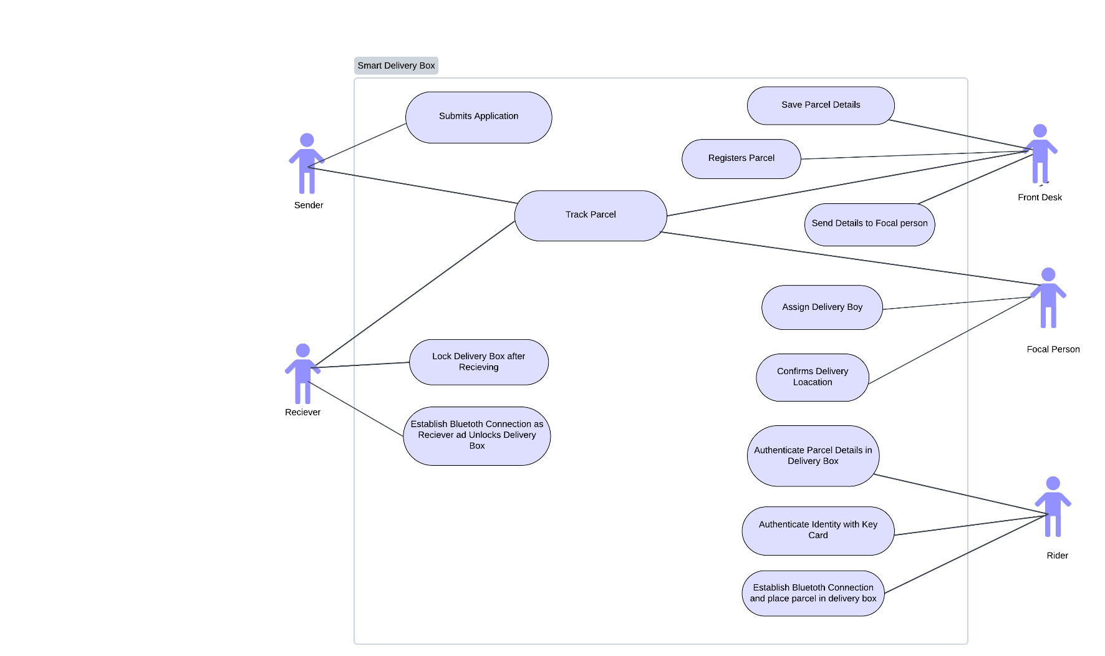

Figure 1

1. Initial research about delivery box Prototype

We have also discussed about our project with manufacturers in China who are already manufacturing these kinds of smart delivery boxes with features we have elaborated in scope of project. One manufacturer is agreed to deliver customized delivery box according to our requirements in Pakistan. The general image of the delivery box is follows.

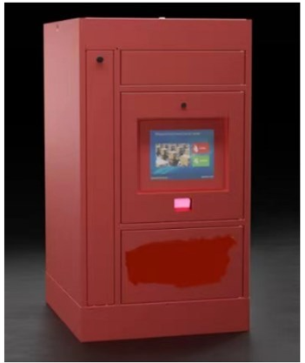

Figure 2

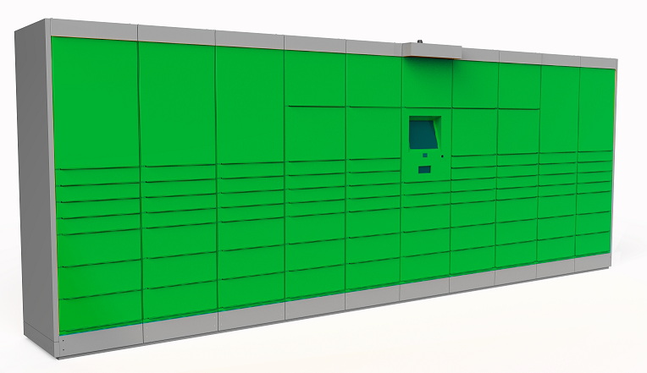

Figure 3

We have just demanded to buy host compartment which is the one having controlling device in above attached image.

# References

# [1] S. Kamal Hayder Kazmi “Strong-growing Pakistan’s E-commerce sector” <https://www.pakistangulfeconomist.com/2023/03/13/strong-growing-pakistans-e-commerce-sector/>

# [2] <https://www.posti.fi/en/private/parcels-and-tracking/track-and-receive/pick-up-the-item>

# [3] <https://www.postnord.fi/en/>

# [4] <https://www.posti.com/en/group-information/history>